**People’s Democratic Republic of Algeria**

**Houch El Mihoub-3- Middle School**

**Level : 4MS Timming : 1h**

First Term English test

**Text:**

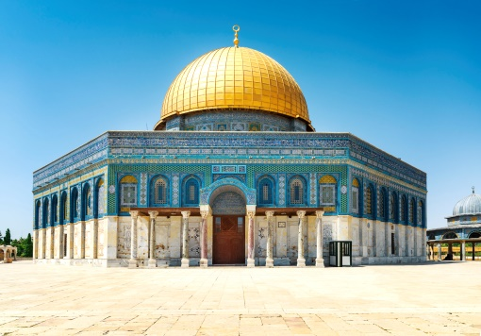 Al-Aqsa Mosque is one of the most popular and major mosques in the world. It is located in the old city of El Quds, Palestine. It covers an area of 144000m and includes the Dome of the Rock ( Qobbat Al Sakhra) and several other landmarks numbering up to 200.

The Dome of the Rock is the oldest Islamic architectural landmark that has kept its original form. It was built by the Caliph Abd el Malik Ibn Marwan in 685 and opened in 771. It was designed by Raja Al Kindi and Yazid Ibn Salam.

It is an octagonal building topped by a circular dome which is 35m high and has a diameter of 20 m. It is made of copper and covered with gold. The mosque has been repeatedly attacked by Israeli occupiers. Despite its restorations it is still under Israeli attack to this day.

**Part one**

**A/Reading Comprehension**

Activity 01: Read the text and say ‘True’ , ‘False’ or ‘ Not mentioned’ (03pts)

1. Al Aqsa mosque is important for Muslims. (…………………….)
2. It is located in Gaza. (……………………..)
3. The Dome was designed in the 500’ (……………………..)

Activity 02: Fill in the table with information from the text (02pts)

|  |  |  |  |  |
| --- | --- | --- | --- | --- |
| Name of the landmark | Date of initiation | Area (m) | Architects |  |
|  |  |  |  |

Activity 03: Find in the text : (02pts)

1. Synonyms to:

Well-known = ………………….. (§1) Constructed = …………..………… (§ 2)

1. Opposites to:

Newest ≠……………………….. (§2) Destructions ≠ ……………………. (§3)

**B/Mastery of Language**

Activity 01: Use the comparative of equality ‘as…as’ or inequality ‘not as…as’: (03pts)

1. China / India ( = populated )

………………..…………………………………………..

1. The Pyramids of Giza / Big Ben ( ≠ attractive )

…………………………………...………………………..

1. William Shakespeare / Pablo Picasso ( = famous )

…………………………………………………………….

Activity 02: Rewrite the sentences differently: (02pts)

1. Guernica was painted in 1932 by Pablo Picasso .

* Pablo ……………………………………………………..

1. The Romans built Tipaza.

* Tipaza ………………………………………….

Activity 03: Classify the words according to the pronunciation of their final ‘-ed’: (02pts)

Populated - Blamed - Decided - Finished

|  |  |  |
| --- | --- | --- |
| **/ t /** | **/ d /** | **/ id /** |
|  |  |  |

**Part two**

Situation of Integration: (06pts)

Algeria is full of incredible landmarks and historic sites that reflect Algeria’s rich history and fascinating nature and culture. The ancient city of Timgad is one of them.

Write a short descriptive paragraph about this special site.

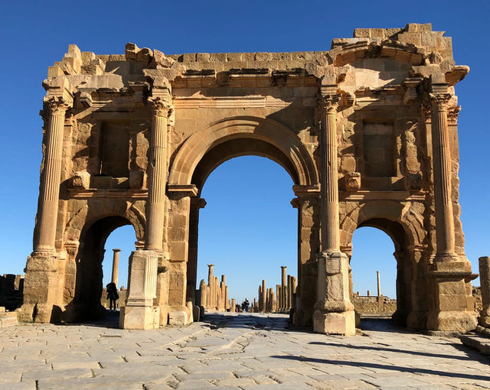 **Monument**: Timgad

**Type:** Historic Roman landmark

**Location:** Aures mountains, Batna

**Founder:** The Roman emperor Trajan

**Date of construction:** 1st Century

**Material**: stones and bricks

**Area:** 2km²

**The use**: as a Roman military defence

**Date of listing by UNESCO:** 1982

****……………………………………………………………………………………………………………………………………………………………………………………………………………………………………………………………………………………………………………………………………………………………………………………………………………………………………………………………………………………………………………………………………………………

Good Luck